**Q1.**

**(a)**

Algorithm: addition(x,n)

Requires: two positive integers x,n

Returns: One integer = x*n

1. If n == 1
2. Return x
3. Else return x + addition(x,n-1)
4. Endif

**(b)**

Algorithm: power(x,n)

Requires: two positive integers x,n

Returns: One integer = x^n

1. If n == 1
2. Return x
3. Else return addition(x, power(x, n - 1))
4. Endif

**(c)**

1. n=4, x=3

2. return addition(3, power(3,3))

3. =3 * power(3,3) = 3 * 27 = 81

4. n=3, x=3

5. return addition(3, power(3,2))

6. =3 * power(3,2) = 3 * 9 = 27

7. n=2, x=3

8. return addition(3, power(3,1))

9. =3 * power(3,1) = 3 * 3 = 9

10. n=1, x=3

11. return 3

12. Return 3 * 3 = 9

13. Return 3 * 9 = 27

14. Return 3 * 27 = 81

15. Return 81

**Q3.**

**(a)**

(i)

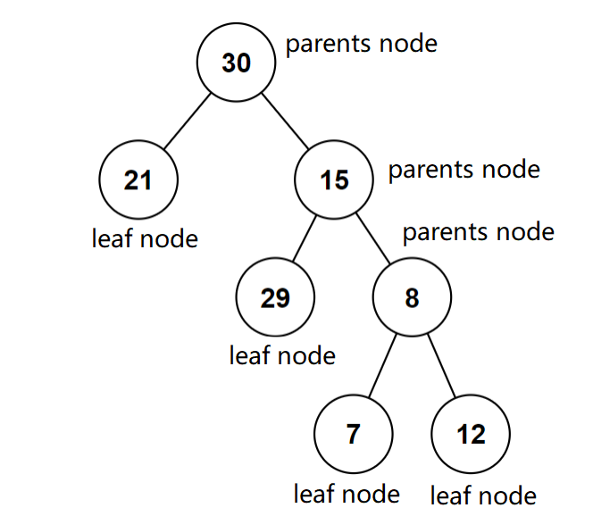

(ii)

21-29-7-12-8-15-30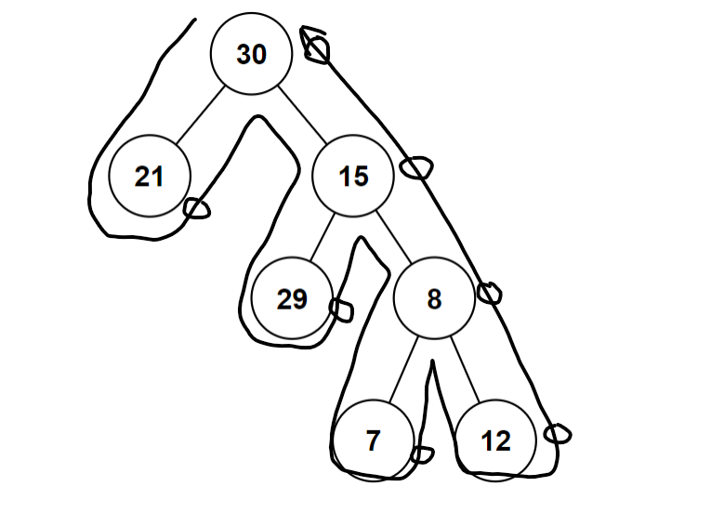

(iii)

30-21-15-29-8-7-12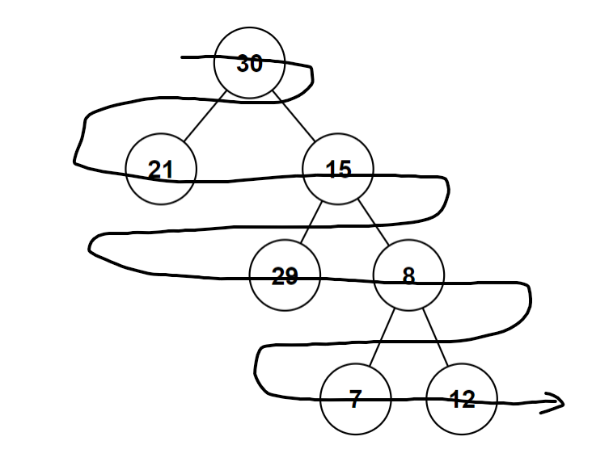

**(b)**

Algorithm: level(x,T)

Requires: a value x and a binary tree T

Returns: One integer = the level to which the value x belongs

1. If search(x,T) == False
2. Return -1
3. Elseif x == root(T)
4. Return 0
5. Else return max(level(x,left(T)+1, level(x,right(T))+1)
6. Endif

**(c)**

Put all the elements in a list using breadth first traversal scheme:

[30,21,15,29,8,7,12]

Sort the list:

[7,8,12,15,21,29,30]

Find the middle element, and store it in root node. 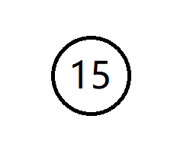

For left/right sub-lists, find the middle elements and store them in the left/right child nodes on next level.

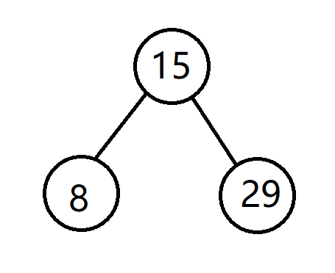

repeat this process until all elements are stored in the tree.

**Q4.**

**(a)**

(i)

This graph is connected, and it has **two** odd vertexes, so it has Euler path.

(ii)

It is NOT a bipartite graph.

It can’t be put into two sets, since there are multiple triangular cycles in the graph.

(iii)

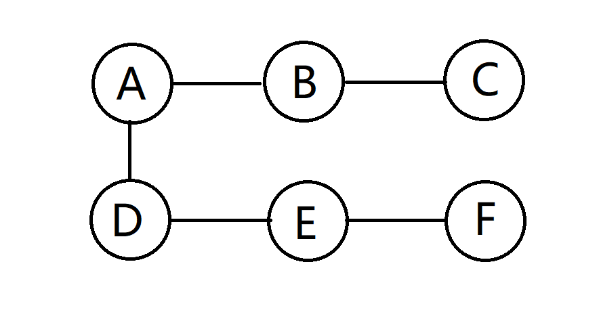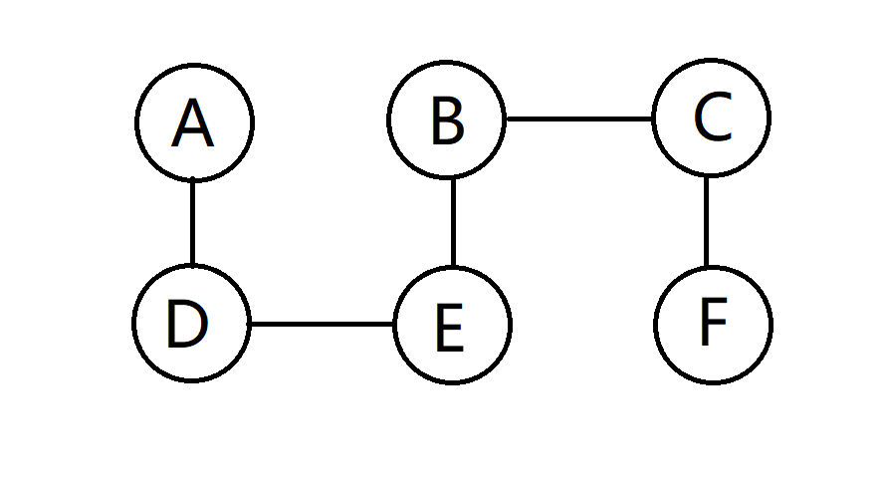

(b)

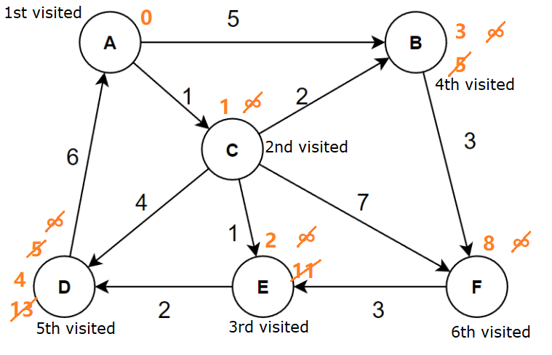

Vertices Shortest path Mininum cost

A to B A-C-B 3

A to C A-C 1

A to D A-C-E-D 4

A to E A-C-E 2

A to F A-C-F 8

(c)

Start with A.

Visited Unvisited Edge selected

A B,C,D,E,F,G,H AC-2

A,C B,D,E,F,G,H AB-3

A,C ,B D,E,F,G,H AG-4

A,C,B,G D,E,F,H GH-2

A,C,B,G,H D,E,F EH-4

A,C,B,G,H,E D,F DE-1

A,C,B,G,H,E,D F BF-6

A,C,B,G,H,E,D,F Done.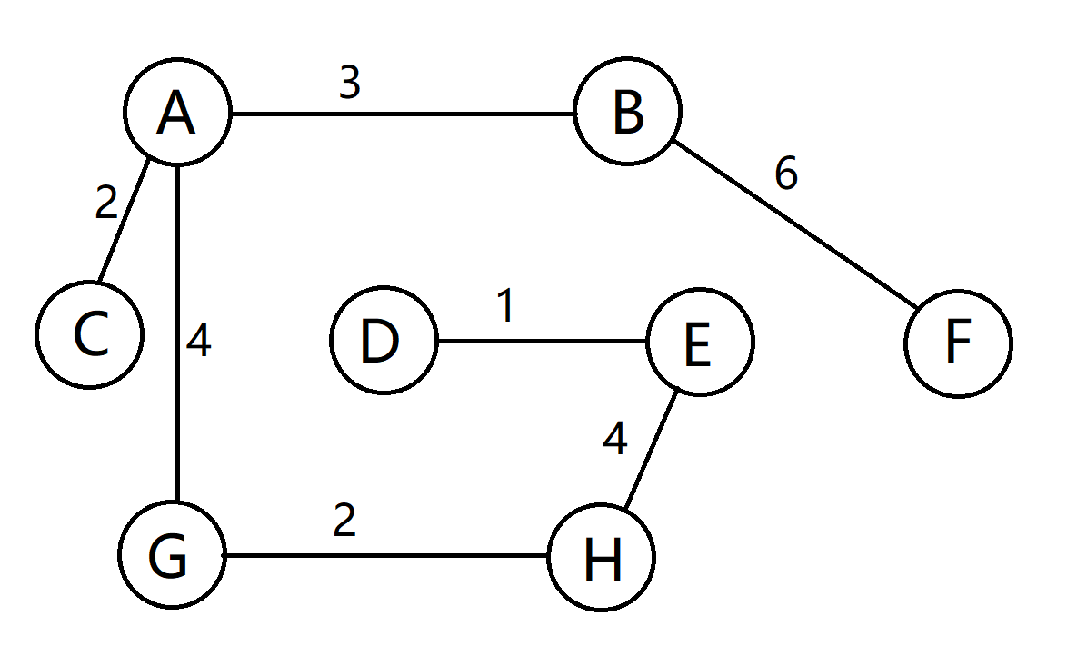

Mininum cost

1+2+2+3+4+4+6=22